**HOW TO CONNECT TO THE RASPBERRY PI USING YOUR NOTEBOOK**

**Step #1 : Powering up the Raspberry Pi**

**Before attempting to power up the Raspberry Pi 4, make sure that the power is turned off**

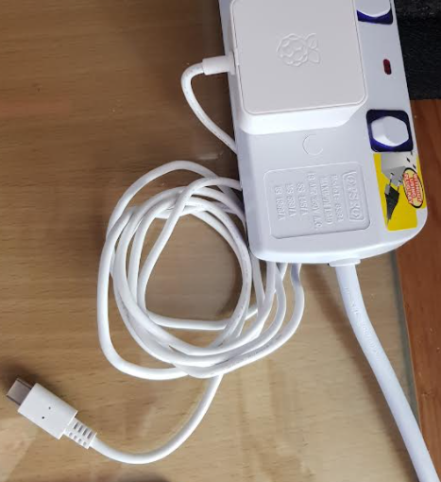

**RASPBERRY PI POWER SUPPLY**

**USB C Type Cable**

**Connect the USB C Cable to the Raspberry Pi 4 as shown below.**

**Once the Cable is firmly in place, switch on the Power Supply.**

**The LED lights on the Raspberry Pi, near the power port will start to blink.**

**It can take upwards from 30 seconds to a minute for the Pi to fully boot up.**

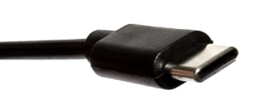 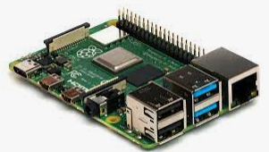

**Step #2 : Joining MakeIt Space Intranet**

**To connect the notebook you are using to the Raspberry Pi, look out for the WIFI / ETHERNET icon shown below. You should see one of these on the task bar**

 **OR** 

**Click on the icon, and look for TRL-Intranet**

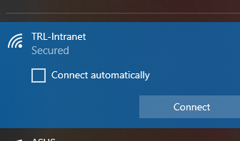

**Click Connect and enter the password**: **TRLNET0401**

**Your notebook will now attempt to connect to the TRL-Intranet Router. You will see a display like this**

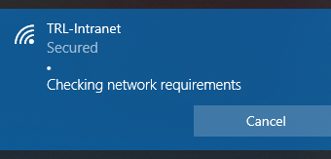

**Once the connection is successful, you will see this**

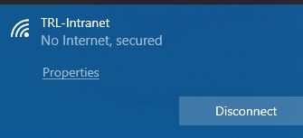

**You will now be able to connect to the Raspberry Pi that has been assigned to you.**

**Step #3 Logging Into your Raspberry Pi**

**On the cover of the container is the IP Address of this particular Raspberry Pi, for example**

**192.168.0.101. You will need this address to connect your notebook to it.**

**We will use a software called VNC to do this.**

**Look for this icon  in your task bar. If you can’t find this, seek help from our facilitator.**

**Click on this icon**

**You should see this on your screen**

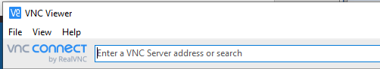

**Enter the IP Address that you see on the Raspberry Pi, or the container that comes with it into the space [Enter a VNC Server address or search] like so:**

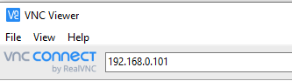

**Make sure that it is the correct IP Address that has been assigned to you. Then, hit Enter key.**

**The VNC software will now look for the Raspberry Pi that has the IP Address that you have just entered.**

**Once connected, VNC will ask you for the user name and password for the Raspberry Pi you are connecting to: type pi as Username and raspberry as Password, like this.**

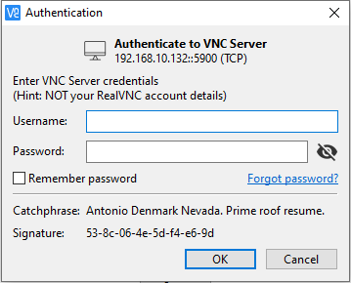

pi

raspberry

**Check Remember password, so that the next time you connect you won’t be asked again.**

**Once successfully connected with your Raspberry Pi, you will this this on your screen**

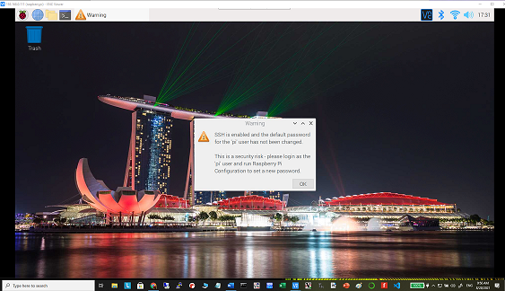

**The IP Address will appear at the top left-hand corner of this screen.**

**Once this happens, you are now in full control of the Raspberry Pi from your notebook.**

**Well Done. Give yourself a pat on the back. 😊**